Troubleshooting Network Failures

Hands On – Troubleshoot a failing Network

I. Deploy the service and pod then identify the svc DNS:
Let’s start by deploying our nginx pods and service.

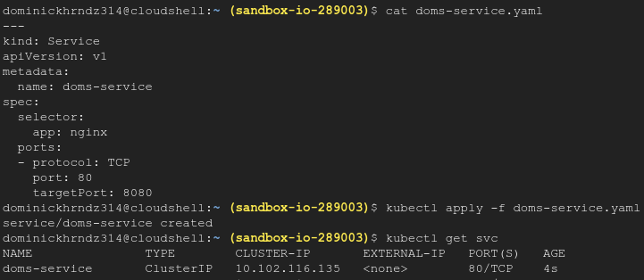
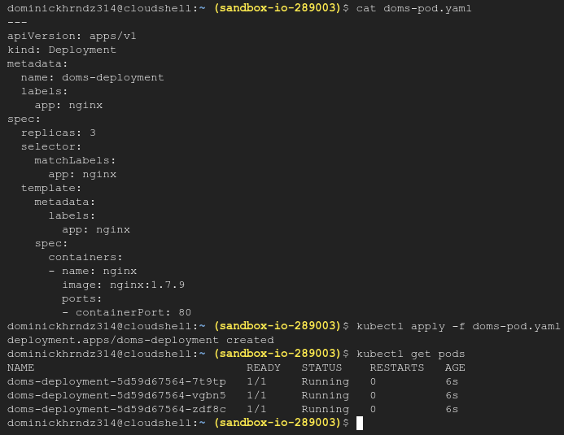

To get the DNS name of our service we need to follow the format according to the Kubernetes documentation:

my-svc.my-namespace.svc.cluster-domain.example

So our DNS address for the service will look something like this:

yourname-service.default.svc.cluster.local

DNS is a service that allows us to resolve hostnames and IP addresses. Let’s ensure that our DNS service is working properly with our new pods. If DNS isn’t working as needed, we will not be able to utilize certain resources in our cluster to access the external internet.

II. Create a pod that has nslookup to test DNS:

Nslookup is a utility used by network engineers to troubleshoot internet connectivity. Essentially, nslookup is like looking up a name and number in a phone book and prints out as such:

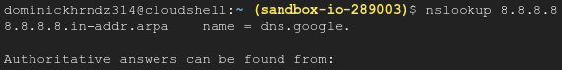

By using nslookup we can ensure our DNS service is working as intended. This manifest creates a pod with all of the DNS utilities for testing.
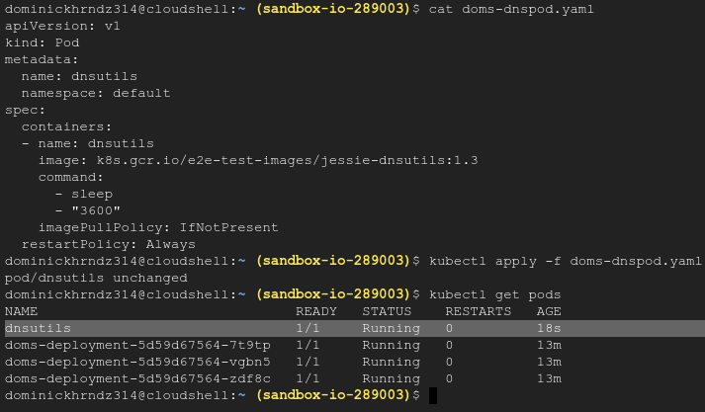

Now that we have the dnsutils pod deployed, let’s SSH into it and get the IP for our service using our hostname.
nslookup yourname-service.default.svc.cluster.local

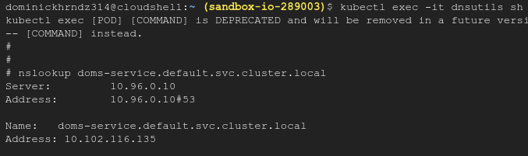
When you run the command you will see an IP printed at the bottom. For my service this IP is 10.102.116.135.

III. Test Connectivity using Curl:

We need to test our connection to the service name on port 80 to ensure the pod is working as expected so that if any other pods or services tried to reach our pods via HTTP, they will have no issues.

Here is how you get a curl command line within a Kubernetes network to test and explore your internal REST endpoints.
To get a prompt of a busybox pod running inside the network, execute the following command.

Bonus: Look into the curl pod’s YAML to better understand this deployment. You can use kubectl edit pod curl to view.

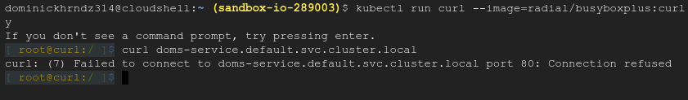
Test connectivity of yourname-service.default.svc.cluster.local on port 80. You should see the curl connection refused.

In your browser, open a second cloud shell.

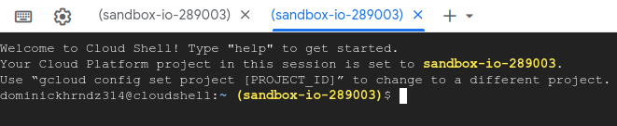
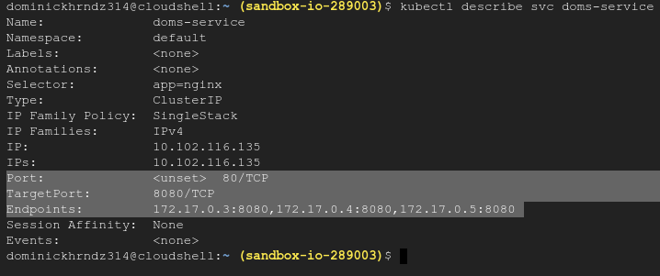
From here check your service by describing it. You can see the service is listening on port 80 and has an endpoint list with a target of port 8080.
Let’s test curl against a pod from the Endpoint field.
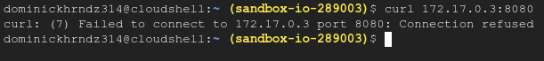
We can see that our connection is being refused because port 8080 isn’t listening. Let’s check that pods config by first listing it in the kubectl get pods -o wide command. This will allow us to identify the pod by the IP address we just used.

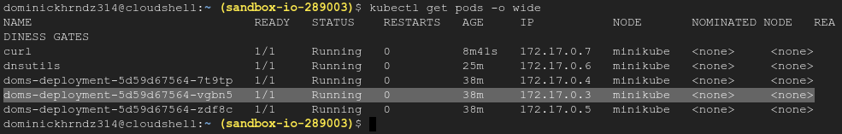

To simplify the process we can use a single command to check the listening port on our pod by first describing, then “grep-ing” or grabbing the port.

kubectl describe pod <podname> | grep -i "port:"

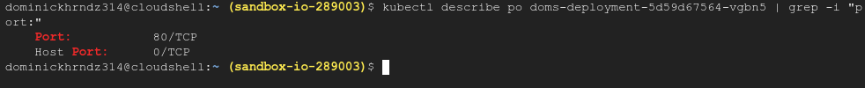
Notice that our service is trying to forward traffic to port 8080 as the target port on the container, but the container is only listening on port 80. This is our issue!

IV. Resolve the Failure:
We need to reconfigure the service and replace the field targetPort: 8080 with targetPort: 80.

Let’s edit the service.

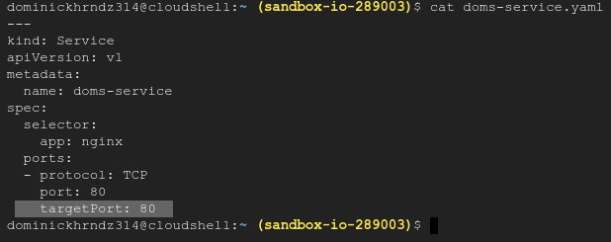
Now lets delete the existing service, re-apply the YAML, and describe the new service.
You should now see the targetPort of 80 listed on all endpoints.

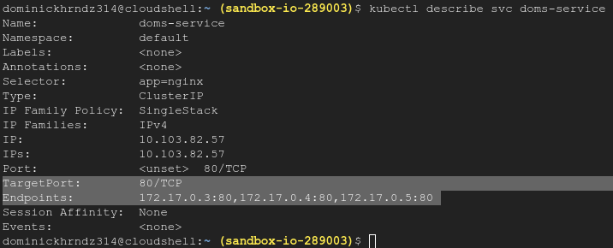
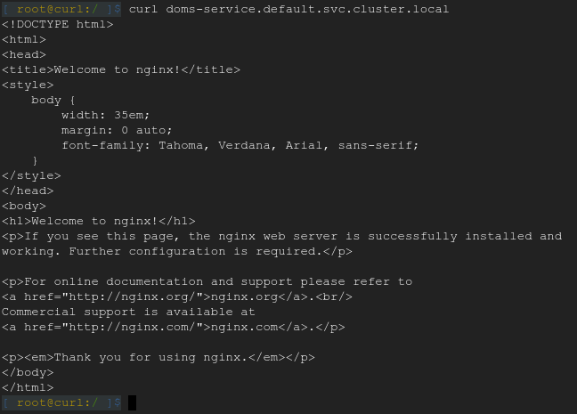
Now go back to the first cloud shell that's running your curl command and retest. If your output looks like the following, you have completed this training.

